The **diameter** of a tree is **the number of edges** in the longest path in that tree.

There is an undirected tree of n nodes labeled from 0 to n - 1. You are given a 2D array edges where edges.length == n - 1 and edges[i] = [ai, bi] indicates that there is an undirected edge between nodes ai and bi in the tree.

Return *the* ***diameter*** *of the tree*.

**Example 1:**

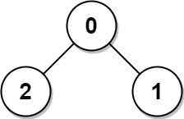

Input: edges = [[0,1],[0,2]]  
Output: 2  
Explanation: The longest path of the tree is the path 1 - 0 - 2.

**Example 2:**

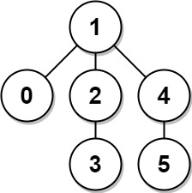

Input: edges = [[0,1],[1,2],[2,3],[1,4],[4,5]]  
Output: 4  
Explanation: The longest path of the tree is the path 3 - 2 - 1 - 4 - 5.

**Constraints:**

* n == edges.length + 1
* 1 <= n <= 104
* 0 <= ai, bi < n
* ai != bi